1. Shared Folders Overview
Screenshot: Overlay of folders to be shared: IT-Docs, HR-Docs, Accounting-Docs, Public.
Description:
- Created departmental shared folders on the file server VM to simulate real-world corporate storage.
- Each folder represents an OU: IT, HR, Accounting, plus a Public share for all users.
- Purpose: organize files per department and demonstrate access control, quotas, and file screening.

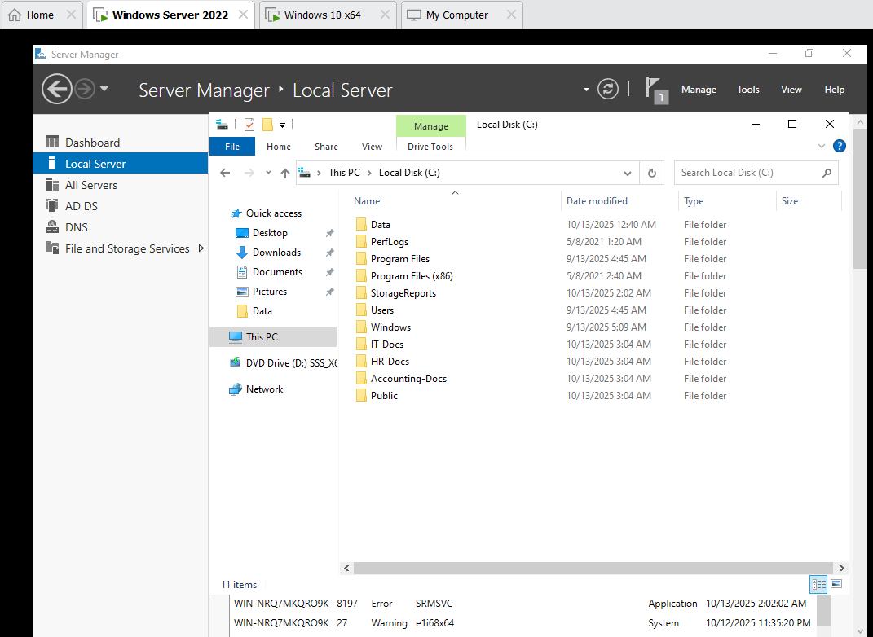

2. Shared Permissions
Screenshot: Three-set screenshot of folder Sharing → Advanced Sharing → Permissions, showing “Everyone = Full Control” for each folder.
Step-by-Step:
- Right-click folder → Properties → Sharing tab → Advanced Sharing.
- Checked “Share this folder.”
- Assigned Everyone = Full Control for simplicity; NTFS will enforce actual access.
Rationale:
- Share permissions are coarse; giving Everyone Full Control allows the NTFS permissions to fully manage actual access while still sharing the folder on the network.

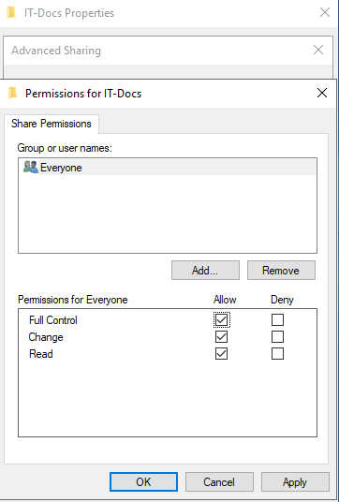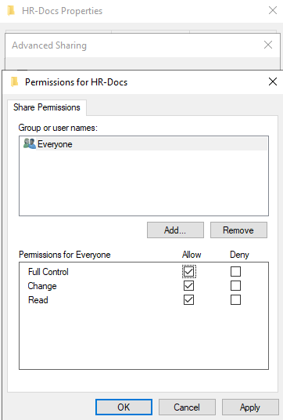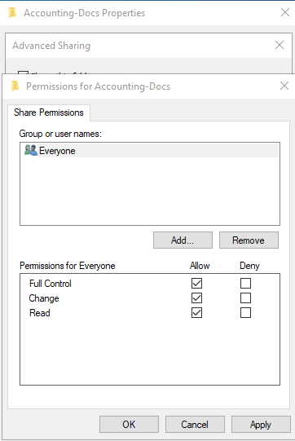
3. NTFS Permissions
Screenshot: Three-set screenshot of Security tab, showing:
- IT Security group has Full Control for IT-Docs
- HR Security group has Full Control for HR-Docs
- Accounting Security group has Full Control for Accounting-Docs
Step-by-Step:
- Right-click folder → Properties → Security tab → Edit → Add → select respective security group.
- Assigned Full Control for that group only.
- Removed unnecessary groups to restrict access.
Rationale:
- NTFS permissions provide fine-grained access control, ensuring only the appropriate departmental users can access their respective folders.

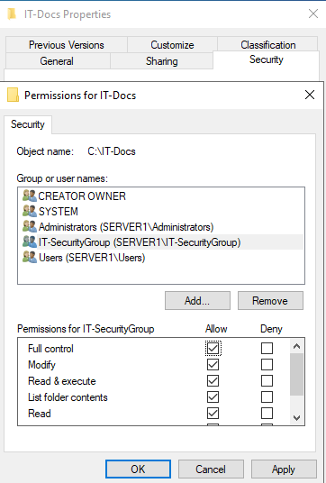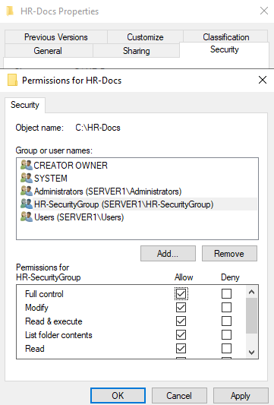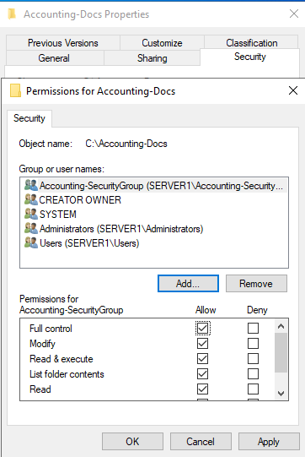
4. Network Drive Mapping via GPO
Screenshot: Two-set screenshot showing creation of IT/HR/Accounting-NetworkDriveMapping GPOs, then Drive Maps settings.
Step-by-Step:
- Open Group Policy Management → right-click OU → Create GPO → Name it Department-NetworkDriveMapping.
- Edit GPO → User Configuration → Preferences → Windows Settings → Drive Maps → New → Mapped Drive.
- Set Location to \\Server\FolderName and assign a drive letter (e.g., Z:).
Rationale:
- Automatically maps departmental shared folders to users’ computers via GPO.
- Ensures consistent access to required resources without manual mapping.

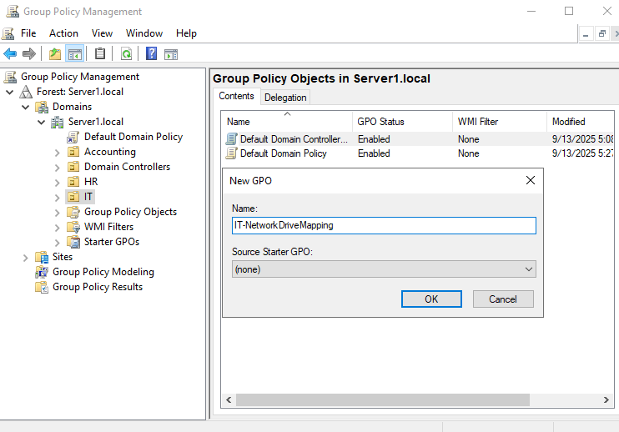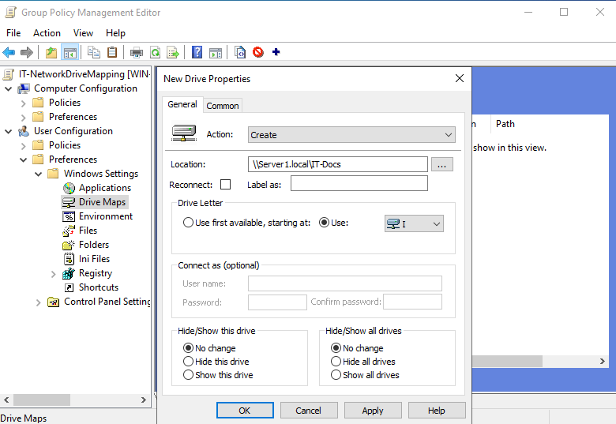
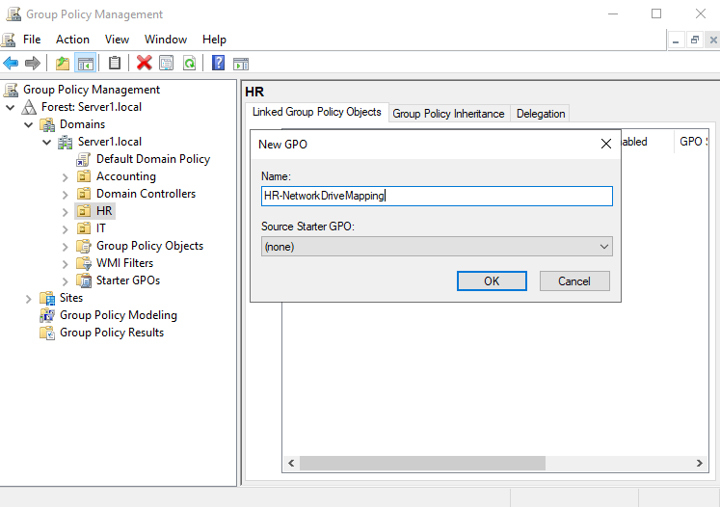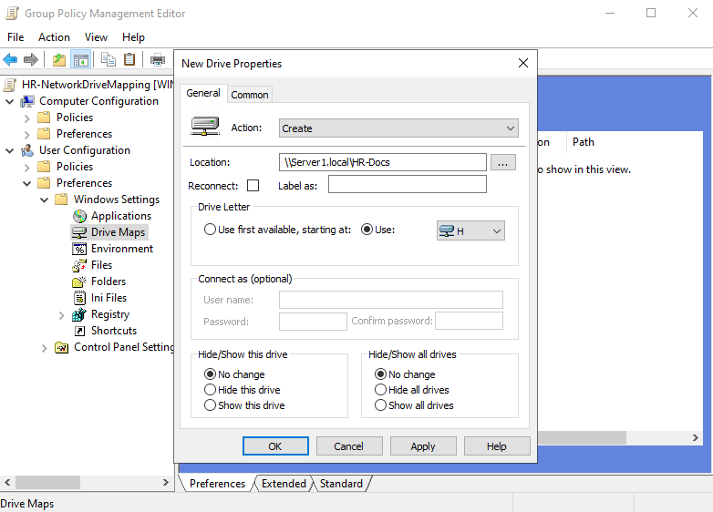
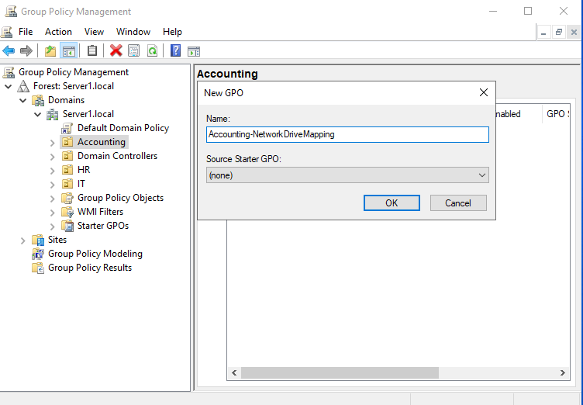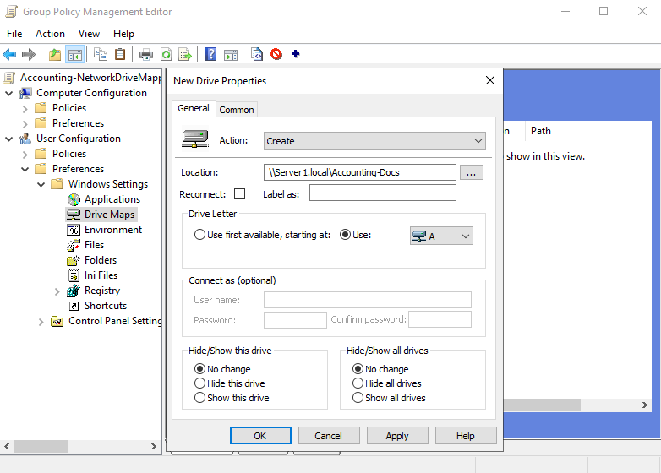
5. Quotas with FSRM
Screenshot: Four-set screenshot: creating three Quota Templates (Accounting/HR/IT-Quota) and assigning them to respective folders; Public folder has a custom max total quota.
Step-by-Step:
- Open FSRM → Quota Management → Create Quota Template.
- Templates created for IT (5GB/user), HR (3GB/user), Accounting (4GB/user).
- Assigned Auto Apply Template to departmental folders to enforce per-user limits automatically.
- Public folder received a max total quota of 10GB, applied manually (not auto-applied).
Rationale:
- Per-user quotas ensure departmental users don’t exceed storage allocation.
- Max total quota on Public folder prevents overall folder from exceeding capacity.

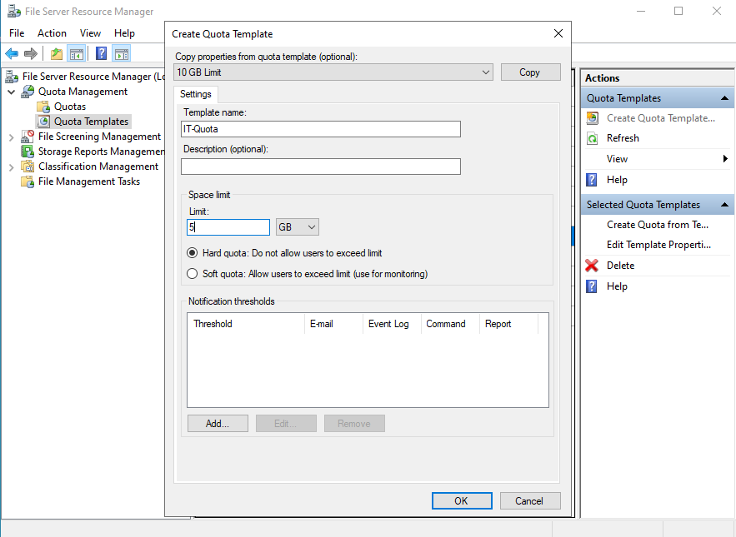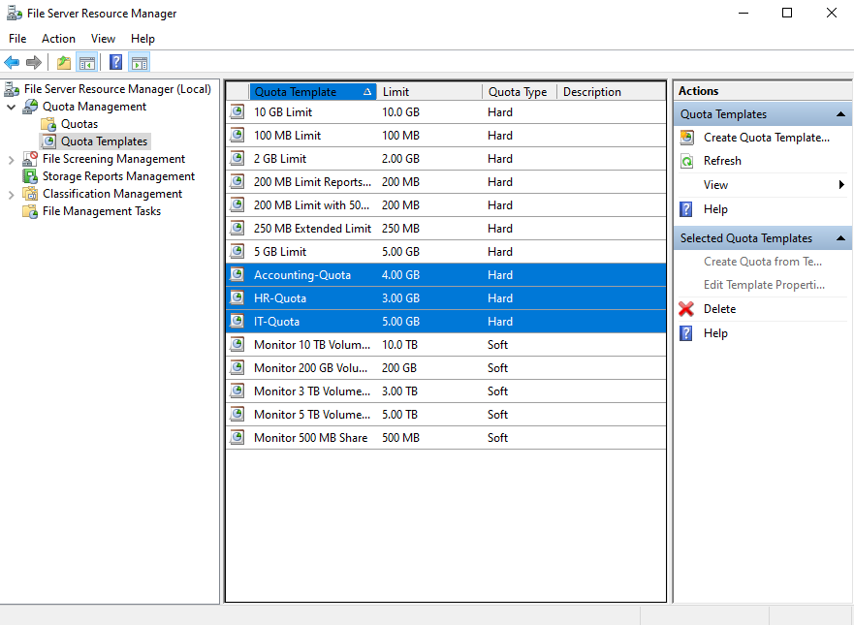
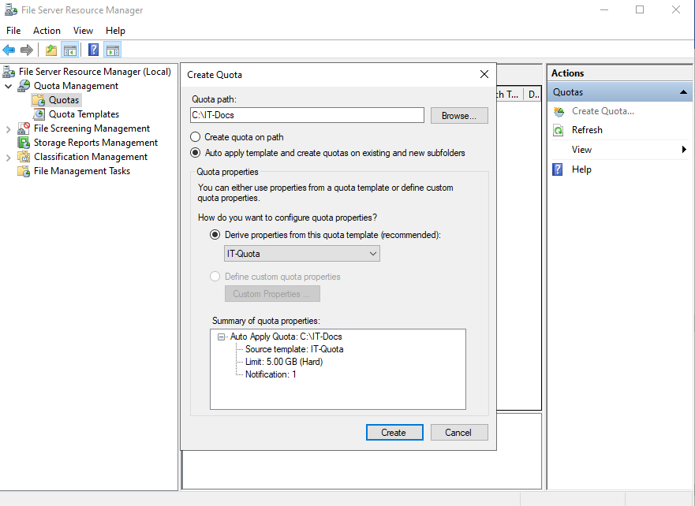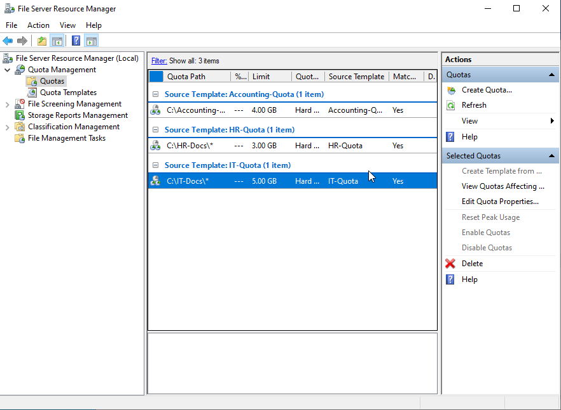
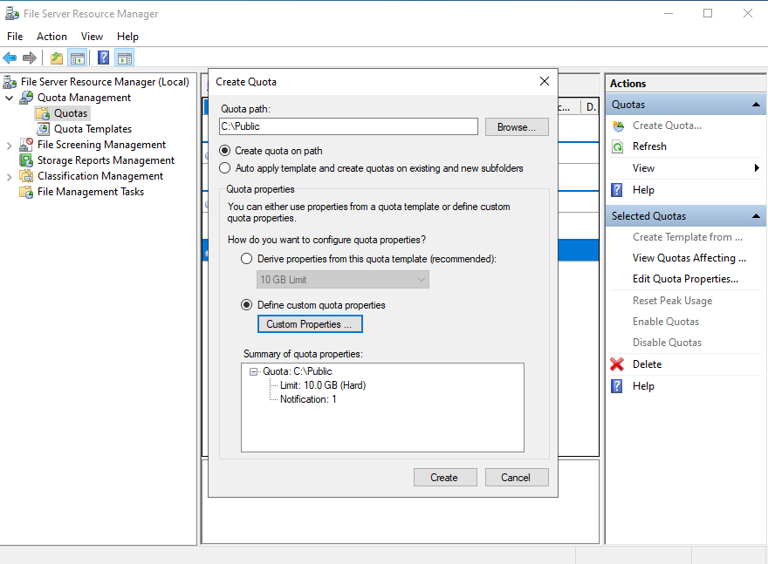
6. File Screening
Screenshot: File groups creation and mapping to file screens:
Department | Blocked File Types
Accounting | 7z, avi, bat, cmd, exe, mp3, mp4, ps1, rar, vbs, zip
HR | 7z, avi, bat, cmd, exe, mov, mp3, mp4, ps1, rar, zip
IT | 7z, bat, cmd, exe, rar, zip

Step-by-Step:
- Open FSRM → File Screening Management → File Groups → Create New File Group.
- Added listed extensions per department.
- Applied the file group to the respective File Screen for each departmental folder → Action: Active (Block).
Rationale:
- IT: block unnecessary archives and executables while allowing essential scripts; balances flexibility with security.
- HR & Accounting: block executables, scripts, media, and archivess to prevent malware and unapproved personal files in sensitive folders.
- Provides realistic corporate file control policies that demonstrate AD-adjacent security skills.

